**What does BloomWatch do?**

BloomWatch is a dynamic visual tool that integrates multiple functions into a single platform. It leverages satellite-based vegetation data from NASA missions such as MODIS, Landsat, and VIIRS to detect and display bloom intensity, timing, and spatial distribution. Users can explore seasonal and yearly bloom patterns through an interactive global map, zoom into specific regions, and view temporal trends. The tool combines vegetation indices (e.g., NDVI/EVI) with climate factors such as temperature, precipitation, and wind patterns to contextualize bloom events and their environmental drivers.

In addition, BloomWatch incorporates advanced ecological analytics, including pollinator dynamics, invasive species detection, aridity indexing, and per-species annual trend visualization, providing a comprehensive global platform to observe and understand Earth’s blooming patterns.

**What functions does it have?**

1. Visual Data: Display selectable data layers for different dates on a global map, including satellite imagery, temperature maps, precipitation maps, NDVI vegetation indices, and more. These layers enable users to explore global data related to floral vegetation and activate dual-map views for comparative analysis.

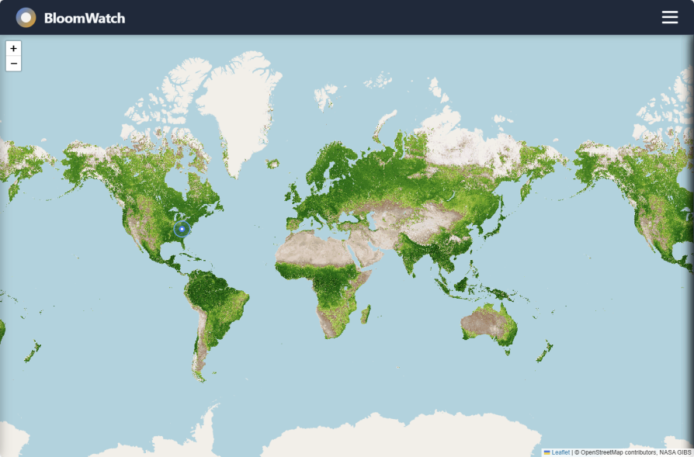

1. Flower Photos: Select any location on the world map to display real-world flower photos nearby. This allows users to observe actual local flower growth conditions and view seasonal blooming patterns by selecting different time periods throughout the year.

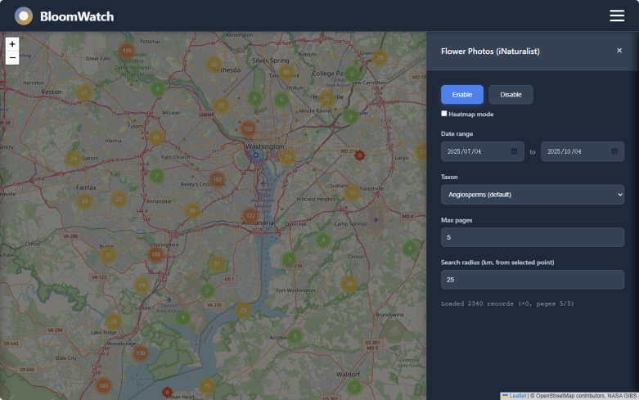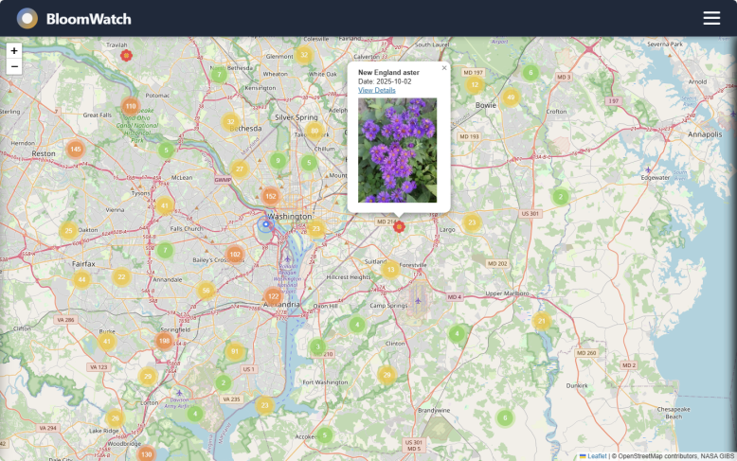

1. Vegetation Indices: Obtain precise NDVI and EVI point values for the selected location to support detailed analysis.

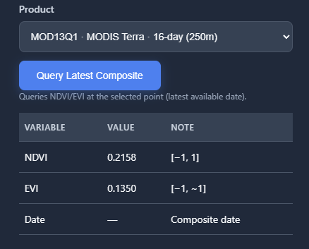

Users can select any point on the map, and BloomWatch will create a circular area centered on that location with a user-defined radius. The system then aggregates vegetation or blooming data **within a single year** for that area and generates a curve chart showing how plant activity changes over time throughout the year.

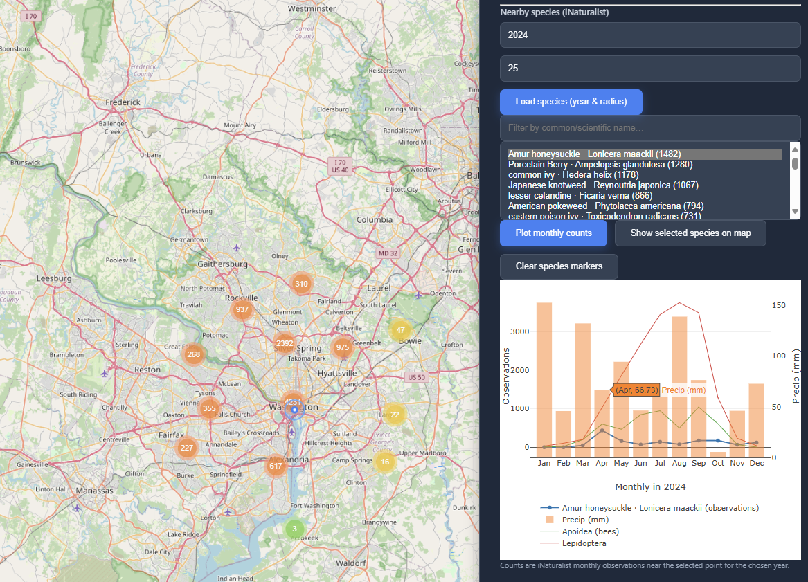

The “Rainfall · Aridity · Superbloom” module uses NASA POWER rainfall data from the past 365 days to estimate the likelihood of large-scale blooming events. By analyzing the share of recent (last 90 days) rainfall within the yearly total, BloomWatch calculates an aridity index and heuristically predicts the probability of a “superbloom” occurring in the selected area.

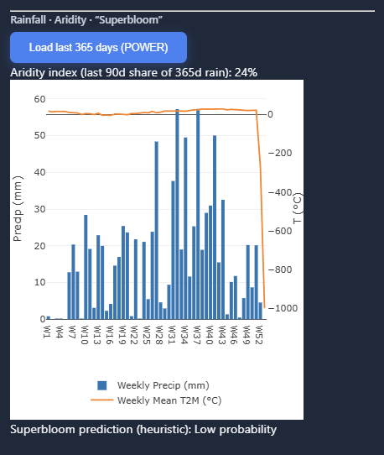

The “Pollinator Dynamics” module allows users to analyze the activity of pollinators based on iNaturalist data. By entering iNaturalist taxa IDs (comma separated), BloomWatch retrieves and visualizes observations of selected pollinator species within a region, helping users compare pollinator activity with local blooming events and study plant-pollinator synchrony.

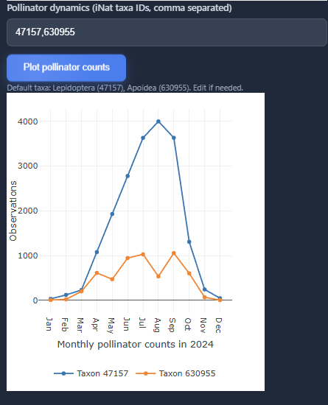

The “Invasives” module automatically analyzes the last five years of iNaturalist observations near a selected point. It ranks species by observation counts, highlighting those flagged as introduced or potentially invasive using heuristic detection or curated invasive species lists. This helps identify ecological risks and visualize invasive species distribution over time.

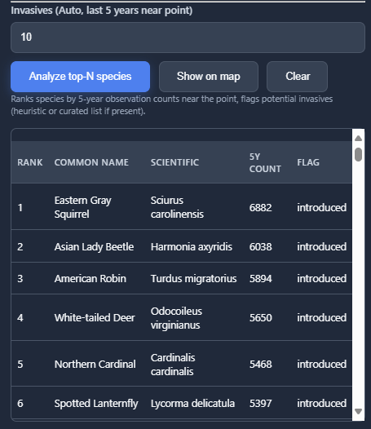

4. Phenology & Predictions: Calculates local flowering times and seasons for plants like cherry blossoms and roses based on current location data using parameters like Base Temperature and GDD Threshold. Users can also input custom data to predict flowering times for specific plants.

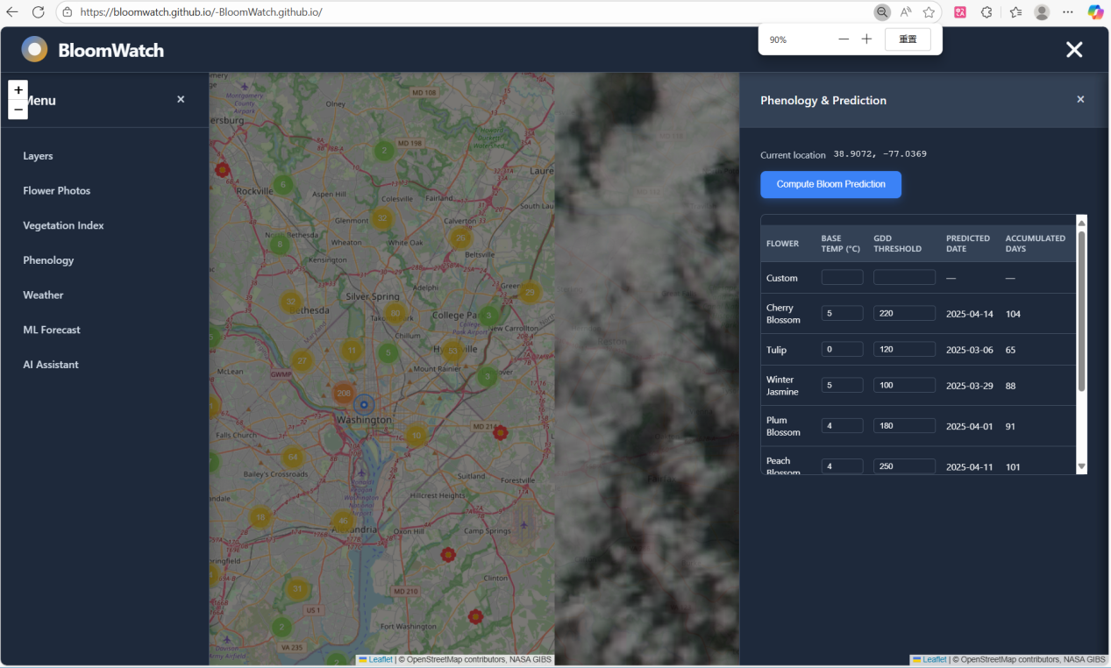

5.Weather: Retrieves temperature and precipitation data for a specified location and date, with the option to generate statistical charts showing recent temperature and precipitation trends.

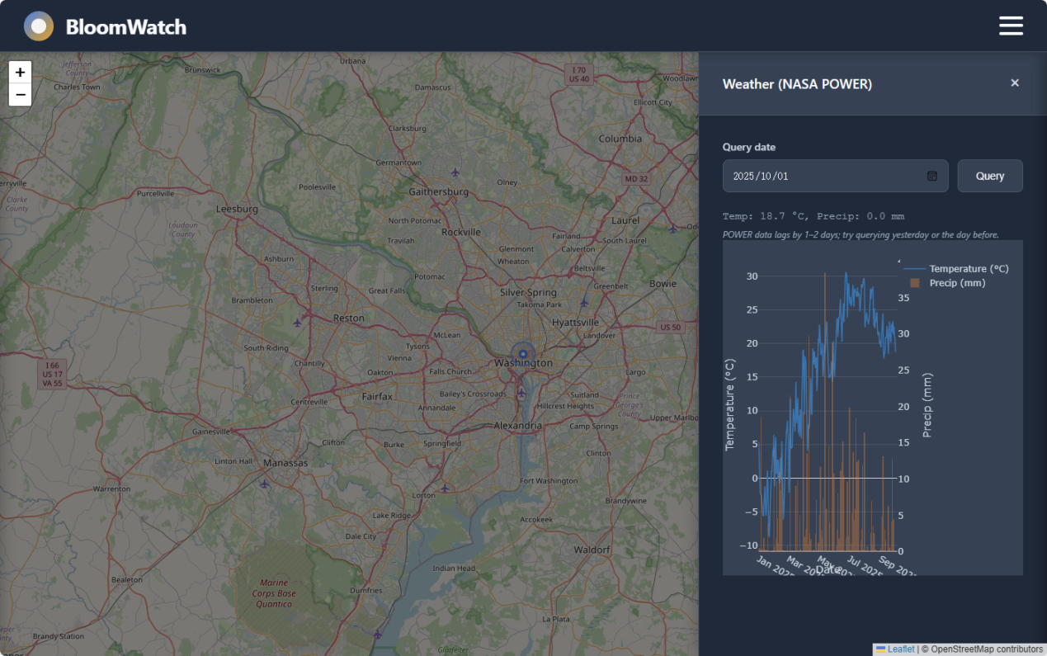

1. Machine Learning Predictions: Utilizes historical multi-year data to predict future NDVI and EVI values through machine learning algorithms.
2. AI Assistant: Powered by ChatGPT API integration, this AI assistant analyzes local environmental data to automatically suggest suitable flowers for planting. Users can also pose additional questions to receive personalized responses.

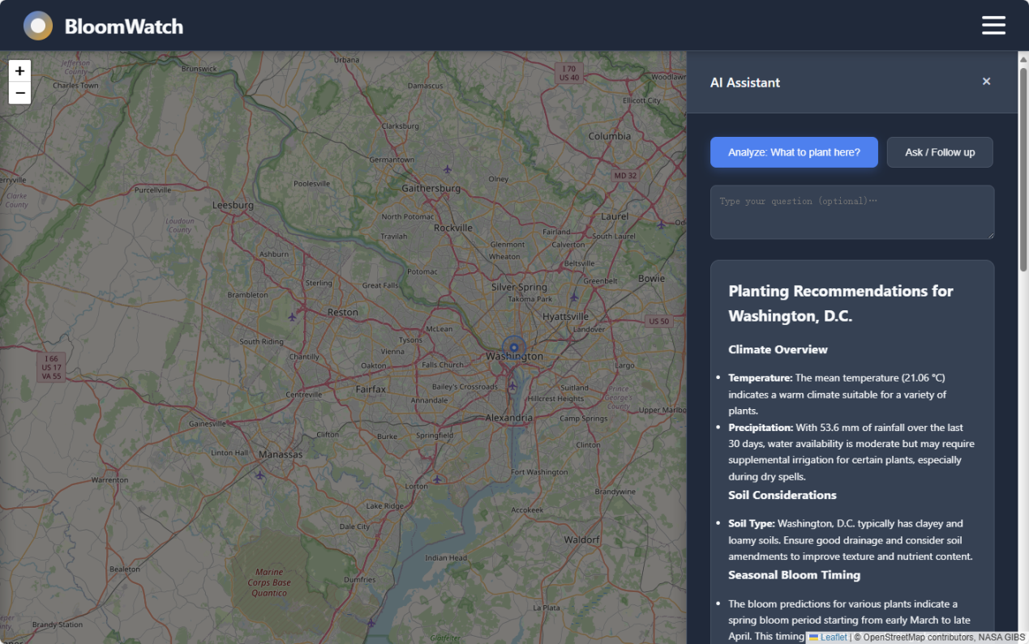

**What does BloomWatch hope to achieve?**

**BloomWatch** aims to enhance global understanding of vegetation dynamics and blooming events by integrating NASA’s satellite data with ecological analytics. It seeks to provide an accessible platform for monitoring, predicting, and managing plant bloom patterns, while supporting research on climate–vegetation interactions, pollinator behavior, and invasive species spread. Ultimately, BloomWatch hopes to empower scientists, conservationists, and the public to make data-driven decisions for ecological preservation and sustainable land management.

**What tools did you use to develop your project?**

Development Tools: Github, Visual Studio Code

Languages: JavaScript, HTML, CSS

Infrastructure: Github

APIs: OpenAI

**Future Goals**

-Real-time bloom and ecological alerts

-Public engagement and mobile participation

-Interactive analytics and reporting tools

**Use of Artificial Intelligence (AI)**

We utilized ChatGPT 5 for various purposes, including troubleshooting, topic research, and writing improvement.

Machine Learning: Least Squares Linear Regression

APIs: OpenAI ChatGPT

**Data**

NASA GIBS https://gibs.earthdata.nasa.gov

NASA POWER https://power.larc.nasa.gov

iNaturalist https://www.inaturalist.org

OpenPortGuide https://weather.openportguide.de

OpenStreetMap Tiles https://openstreetmap.org

OSM Nominatim https://nominatim.openstreetmap.org